* [Produce a timestamp for 1 a.m. on the 31st of August 2012](https://pgexercises.com/questions/date/timestamp.html)

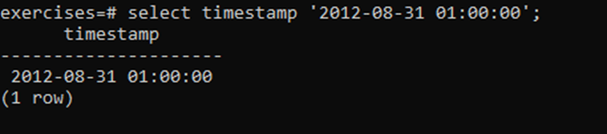

* [Subtract timestamps from each other](https://pgexercises.com/questions/date/interval.html)

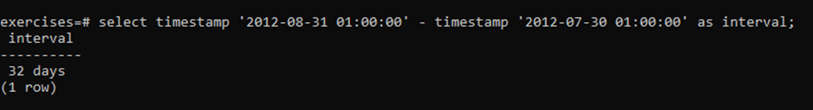

* [Generate a list of all the dates in October 2012](https://pgexercises.com/questions/date/series.html)

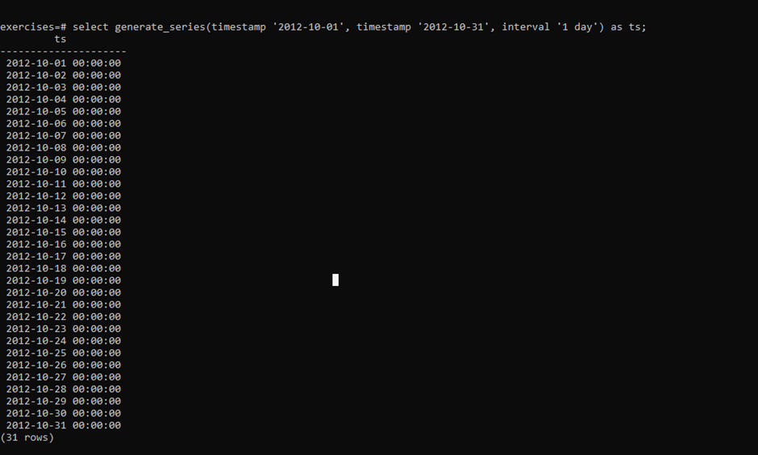

* [Get the day of the month from a timestamp](https://pgexercises.com/questions/date/extract.html)

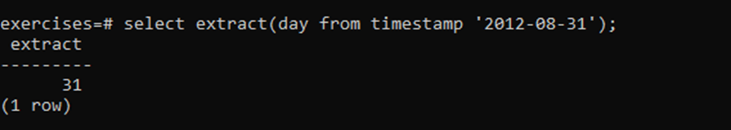

* [Work out the number of seconds between timestamps](https://pgexercises.com/questions/date/interval2.html)

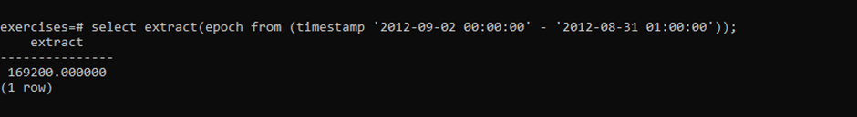

* [Work out the number of days in each month of 2012](https://pgexercises.com/questions/date/daysinmonth.html)

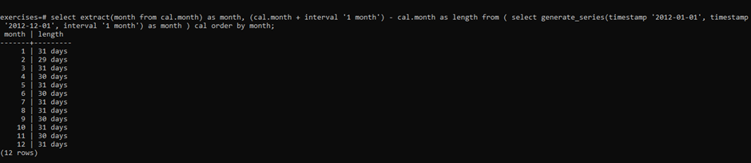

* [Work out the number of days remaining in the month](https://pgexercises.com/questions/date/daysremaining.html)



* [Work out the end time of bookings](https://pgexercises.com/questions/date/endtimes.html)

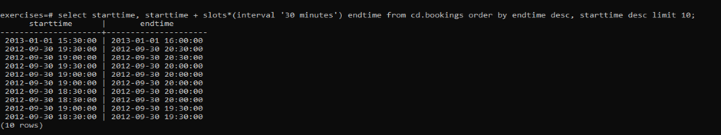

* [Return a count of bookings for each month](https://pgexercises.com/questions/date/bookingspermonth.html)

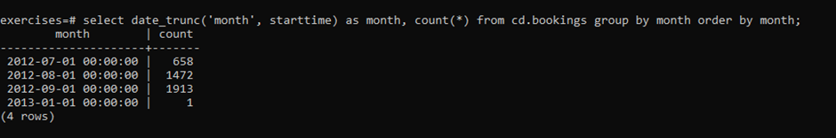

* [Work out the utilisation percentage for each facility by month](https://pgexercises.com/questions/date/utilisationpermonth.html)

